online shopping system unified modelling language uml diagram

use case diagram of online shopping system

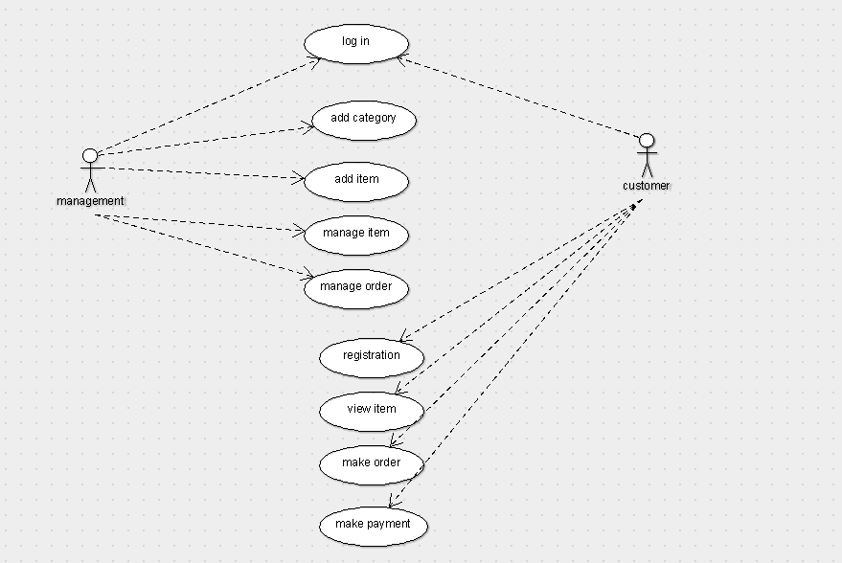

Class diagram of online shopping system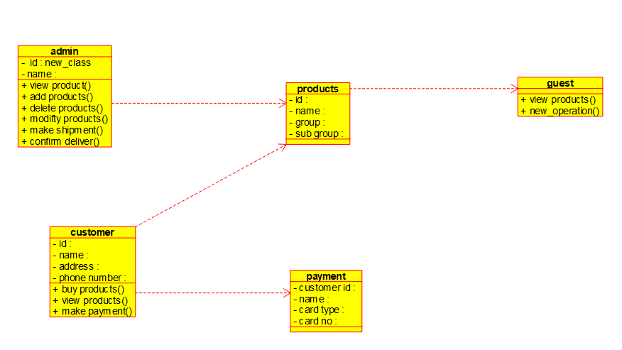

Activity diagram of online shopping system

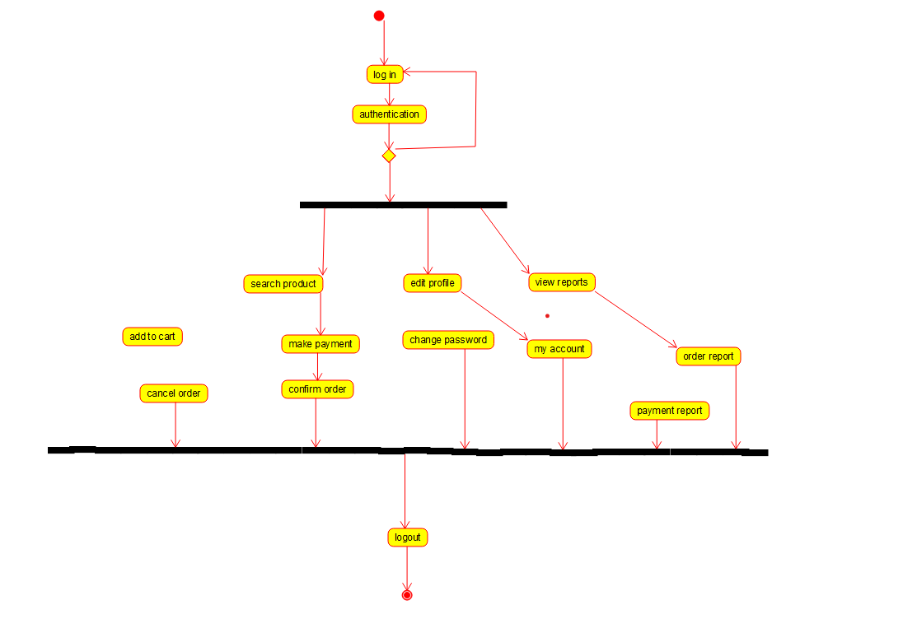

Deployment diagram of online shopping system

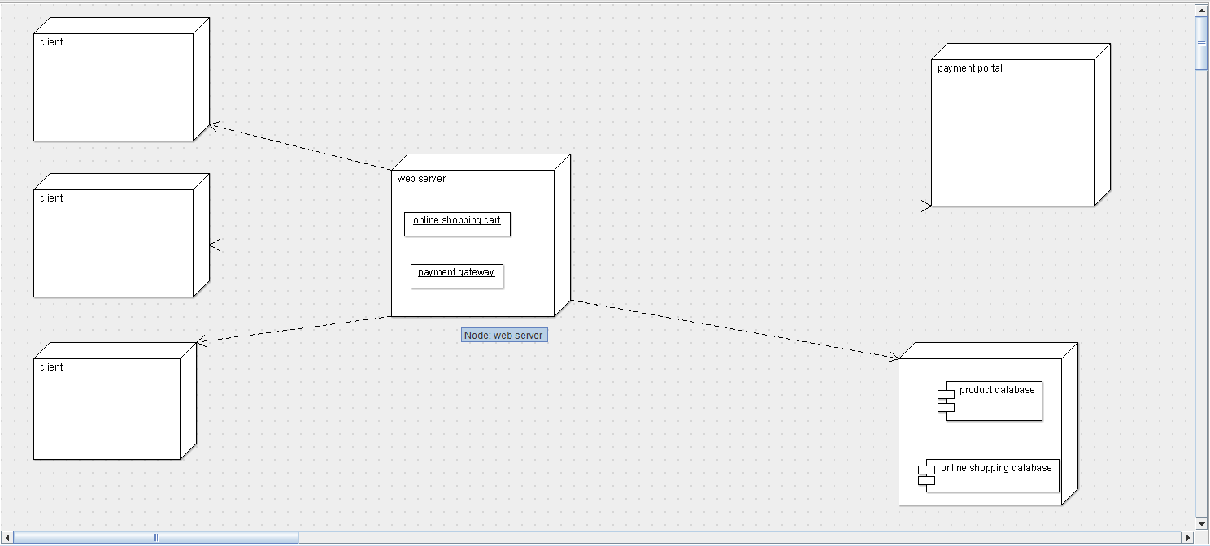

Component diagram of online shopping system

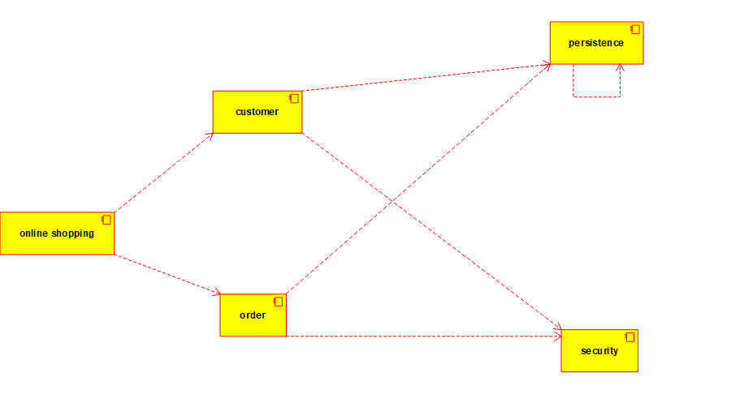

Sequence diagram of online shopping system

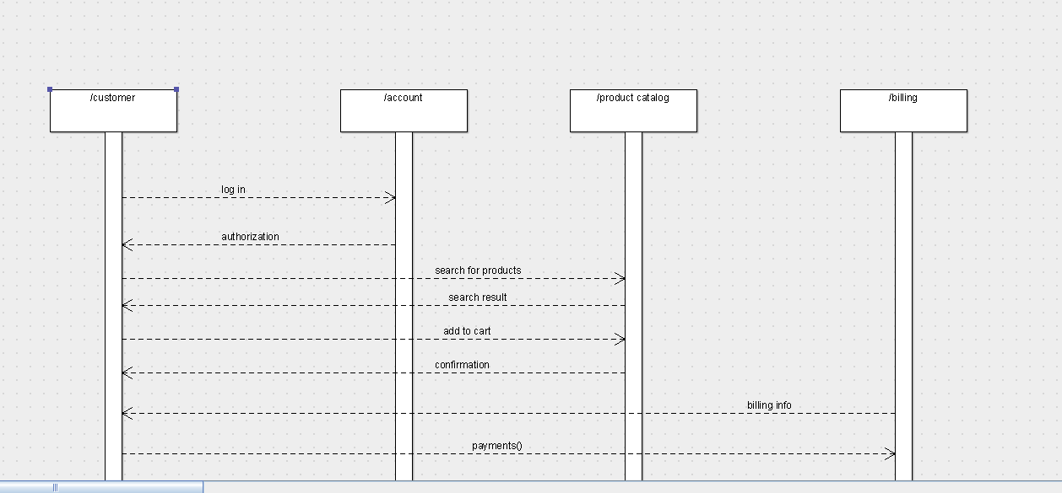

State chart diagram of online shopping system

